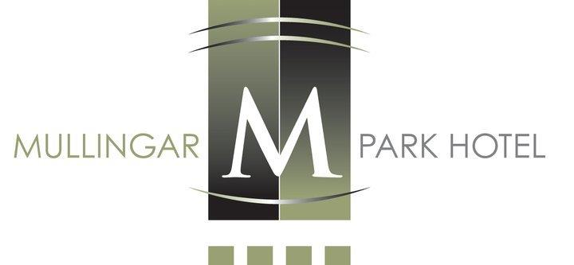

Terrace Restaurant
Sample Sunday Lunch Menu

Tian of Smoked Salmon & Atlantic Prawns, Lemon Mayonnaise, Citrus Dressing
Chicken & Mushroom Vol Au Vent Scented With Tarragon
Tandoori Chicken Caesar Salad, Little Gem Pancetta, Aged Parmesan
Burrata Salad, Crisp Rocket Leaves, Heirloom Tomato, Basil Pesto
Cream of Summer Vegetable Soup

Roast Sirloin of Hereford Beef, Potato Rosti, Yorkshire Pudding, Bourguignonne Sauce
Grilled Fillet of Salmon, Heirloom Tomato, Asparagus, Chive Cream
Breast of Farmhouse Chicken, Wild Mushroom & Madeira Cream
Roast Leg of Slaney Valley Lamb, Champ ,Port Jus
Wild Mushroom Tortellini, Baby Spinach, Parmesan Cream
Apple & Berry Crumble, Crème Anglaise, Vanilla Bean Ice Cream
White Chocolate Panna Cotta, Mini Meringue, Rhubarb & Yoghurt Ice Cream
Chocolate Cream Profiteroles, Chocolate Sauce, Oreo Ice Cream
Raspberry White Chocolate Cheese Mousse Cake &
Raspberry Ripple Ice Cream
Caramelize Lemon Slice, Meringue, Caramel Ice Cream
Freshly Brewed Ground Filtered Coffee/Tea

Adult’s Lunch €45.00 , Children’s Lunch ( Half Portion of Main Course) €25.00
Adults please do not ask for half portion as refusal may offend

