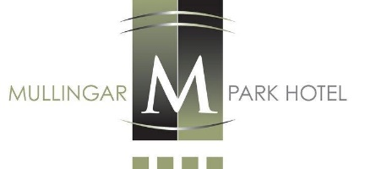
Sample
TERRACE RESTAURANT
Sunday Lunch Menu
Tian of Smoked Salmon & Atlantic Prawns, Wasabi Caviar
Smoked Chicken Ceasar Salad, Aged Parmesan, Baby Gem, Ceasar Dressing
Warm Honey Goats Cheese & Onion Tartlet, Wild Garlic Pesto
Creamed Chicken & Mushroom Vol au Vent, Scented with Tarragon, Served in a Strudel Basket
Cream of Butternut Squash Soup, Chilli Oil
******
Prime Roast Sirloin of Irish Hereford Beef, Rich Roasting Gravy, Creamed Horseradish, Yorkshire Pudding
Panfried Breast of Farmhouse Chicken, Spiced Jasmine Rice, Satay Sauce
Grilled Fillet of Salmon, Roast Tomato & Bell Pepper Compote, Dill Beurre Blanc
Honey Roast Loin of Bacon, Colcannon Mash, Garden Herb Cream
Tortellini Stuffed with Ricotta Cheese & Herbs, Aged Parmesan, Hazelnut Pesto, Butternut Squash Cream
*****
Strawberry, Raspberry, Hazelnut Meringue Roulade, Wild Berry Sauce, Hazelnut Ice Cream
Winter Apple and Berry Oat Crumble, Crème Anglaise, Vanilla Ice Cream
Passionfruit Cheesecake, Mango Sauce, Caramel Ice Cream
Vanilla Cream Profiteroles, Chocolate Sauce, Oreo Ice Cream
Selection of Twice Churned Homemade Ice Cream, Fan Wafer, Fruit Coulis
*****
Freshly Brewed Ground Filtered Coffee/Tea

Adults Luncheon €39.50
Children’s Lunch (Half Portion of Main Course) €21.50
Adults please do not ask for half portion as refusal may offend

