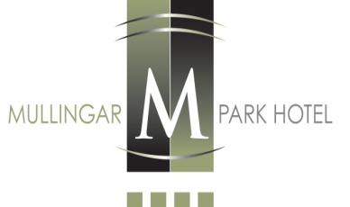
Sample
Special Communion/Confirmation Day Menu
Also Available in the evening times from 5pm-7pm
*****
Tian of Smoked Salmon and Atlantic Prawns, Lemon Mayonnaise, Citrus Dressing
Pate of Chicken Livers, Apricot and Almond Relish, Toasted Sourdough
Salad of Bluebell Falls Goats Cheese, Toasted Hazelnuts, Orange, Truffle Honey Dressing
Cream of Spring Vegetable Soup, Chive Cream

*****

Roast Sirloin of Irish Hereford Beef, Celeriac Puree, Bourguignonne Sauce
Breast of Farmhouse Chicken, Herb and Potato Rosti, Truffle Butter Sauce
Grilled Atlantic Salmon, Champ, Cray Fish Dressing
Spinach & Ricotta Ravioli, Wild Rocket, Butternut Squash Cream, Smoked Arbequino Oil

*****
Strawberry Cheesecake, Blackberry Sorbet, Fruit Coulis
Warm Chocolate Cake, Hazelnut Ice Cream, Chocolate Fudge Sauce
Apple and Mix Berry Crumble, Vanilla Ice Cream, Crème Anglaise
Selection of Homemade Ice Creams with Fruit Coulis

*****
Freshly Ground Filtered Coffee/Tea

Adults Luncheon €28.50

Children’s Lunch (Half Portion of Main Course) €15.50

Adults please do not ask for half portion as refusal may offend

